**Create Eureka Discovery Server and register microservices**

**Objective:**

To create a **Eureka Discovery Server** for service registration and discovery, enabling microservices (like AccountService and LoanService) to dynamically register and communicate without hardcoding URLs.

**Steps involved:**

i)Create a Spring Project for Eureka-Discovery-Service using <https://start.spring.io/> with dependency EurekaServer

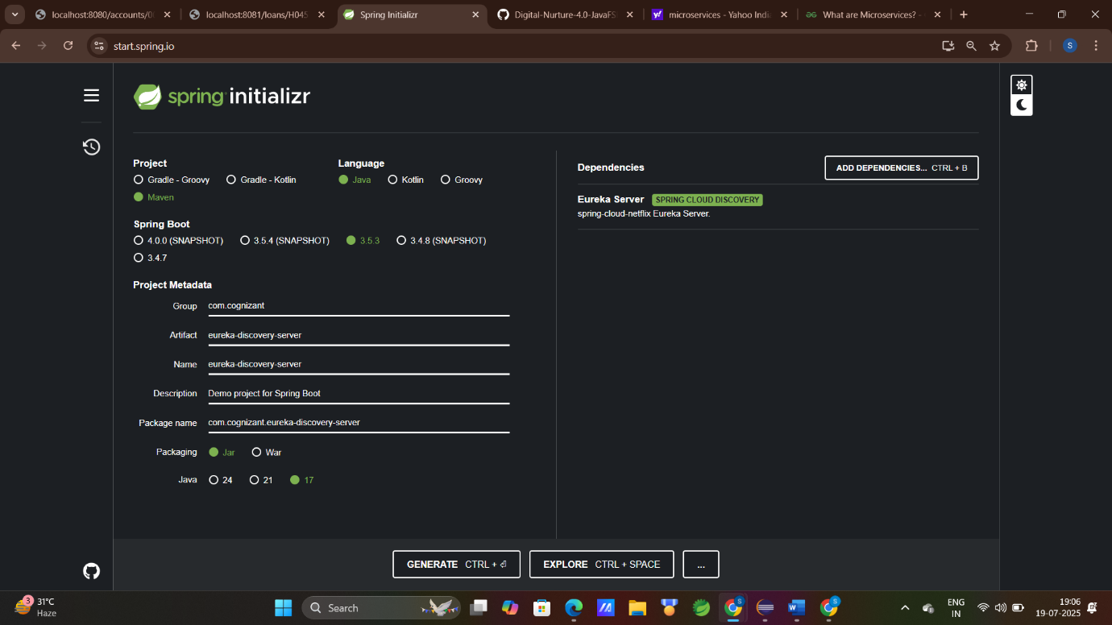

ii) Import project in Eclipse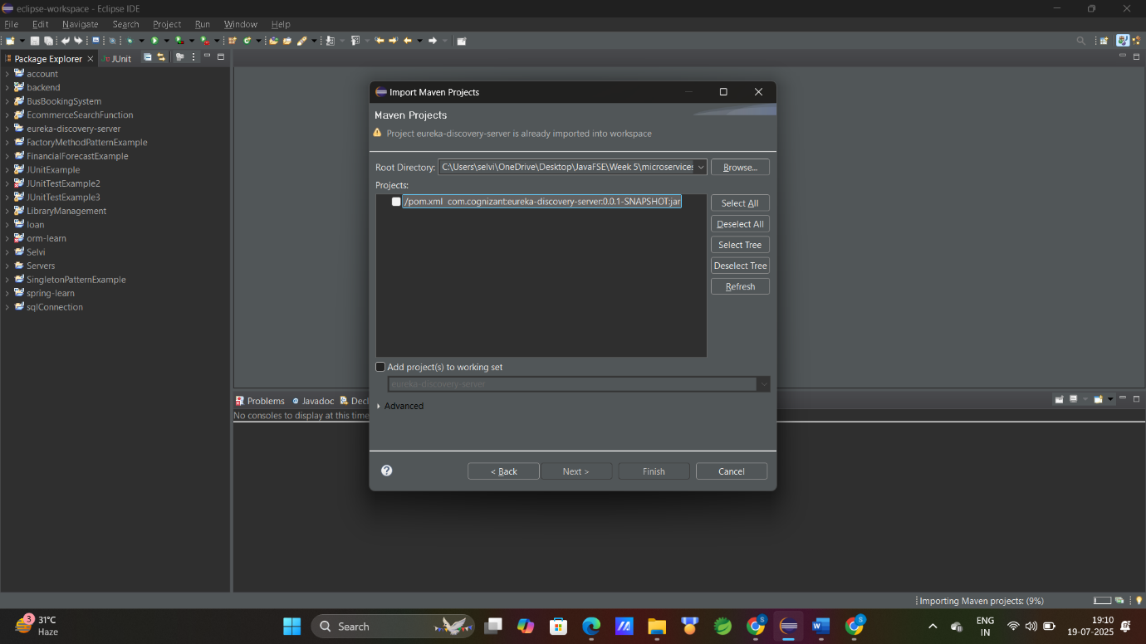

iii)Setup the Eruka-Discovery-Server

application.properties

spring.application.name=eureka-discovery-server

server.port=8761

eureka.client.register-with-eureka=false

eureka.client.fetch-registry=false

logging.level.com.netflix.eureka=OFF

logging.level.com.netflix.discovery=OFF

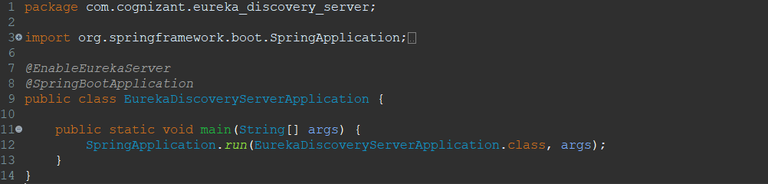

iv)Create two microservices for accout and loan:

dependencies:Spring Boot DevTools, Eureka DiscoveryClient,SpringWeb

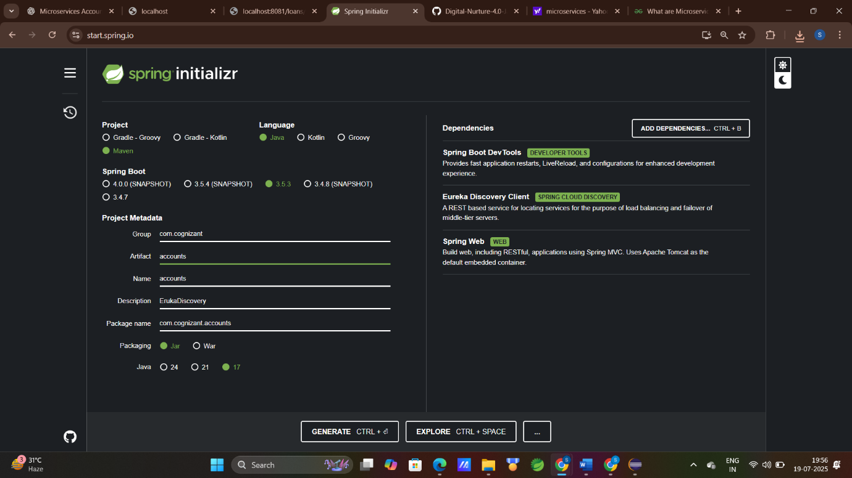

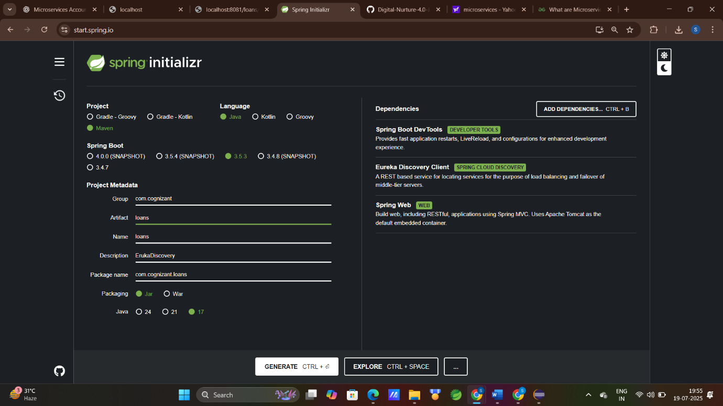

v)Setup accounts and loans

* MicroService : Accounts

package com.cognizant.accounts;

import org.springframework.boot.SpringApplication;

import org.springframework.boot.autoconfigure.SpringBootApplication;

import org.springframework.cloud.client.discovery.EnableDiscoveryClient;

*@SpringBootApplication*

*@EnableDiscoveryClient*

public class AccountsApplication {

public static void main(String[] args) {

SpringApplication.*run*(AccountsApplication.class, args);

}

}

package com.cognizant.accounts.controller;

import org.springframework.web.bind.annotation.GetMapping;

import org.springframework.web.bind.annotation.PathVariable;

import org.springframework.web.bind.annotation.RequestMapping;

import org.springframework.web.bind.annotation.RestController;

*@RestController*

*@RequestMapping*("/accounts")

public class AccountController {

*@GetMapping*("/{accountNumber}")

public String getAccount(*@PathVariable* String accountNumber) {

return "Account details for " + accountNumber;

}

}

Application.properties : accounts

spring.application.name=accounts

server.port=8081

spring.application.name=account-service

eureka.client.service-url.defaultZone=http://localhost:8761/eureka

* MicroService: Loans

package com.cognizant.loans;

import org.springframework.boot.SpringApplication;

import org.springframework.boot.autoconfigure.SpringBootApplication;

import org.springframework.cloud.client.discovery.EnableDiscoveryClient;

*@SpringBootApplication*

*@EnableDiscoveryClient*

public class LoansApplication {

public static void main(String[] args) {

SpringApplication.*run*(LoansApplication.class, args);

}

}

package com.cognizant.loans.controller;

import org.springframework.web.bind.annotation.GetMapping;

import org.springframework.web.bind.annotation.PathVariable;

import org.springframework.web.bind.annotation.RequestMapping;

import org.springframework.web.bind.annotation.RestController;

*@RestController*

*@RequestMapping*("/loans")

public class LoanController {

*@GetMapping*

("/{loanNumber}")

public String getLoan(*@PathVariable* String loanNumber) {

return "Loan details for " + loanNumber;

}

}

Application.properties : loans

spring.application.name=loans

server.port=8082

spring.application.name=loan-service

eureka.client.service-url.defaultZone=http://localhost:8761/eureka

vi) Run the Project one-by-one

OutPut:

Port : <http://localhost:8761/>

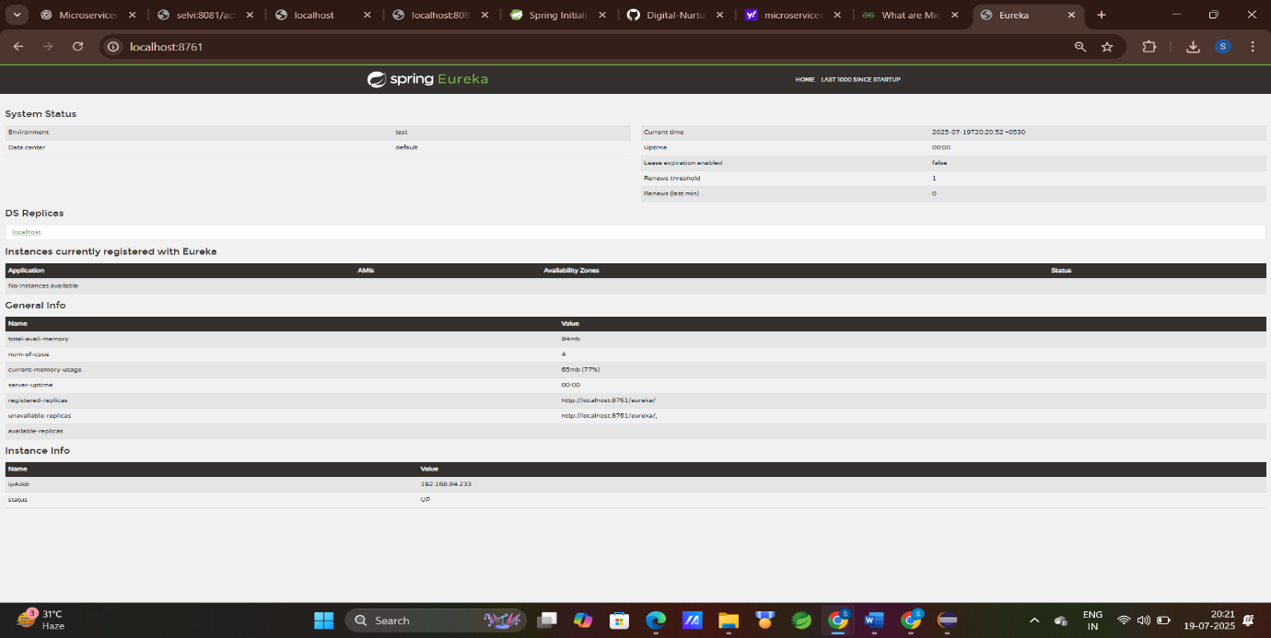

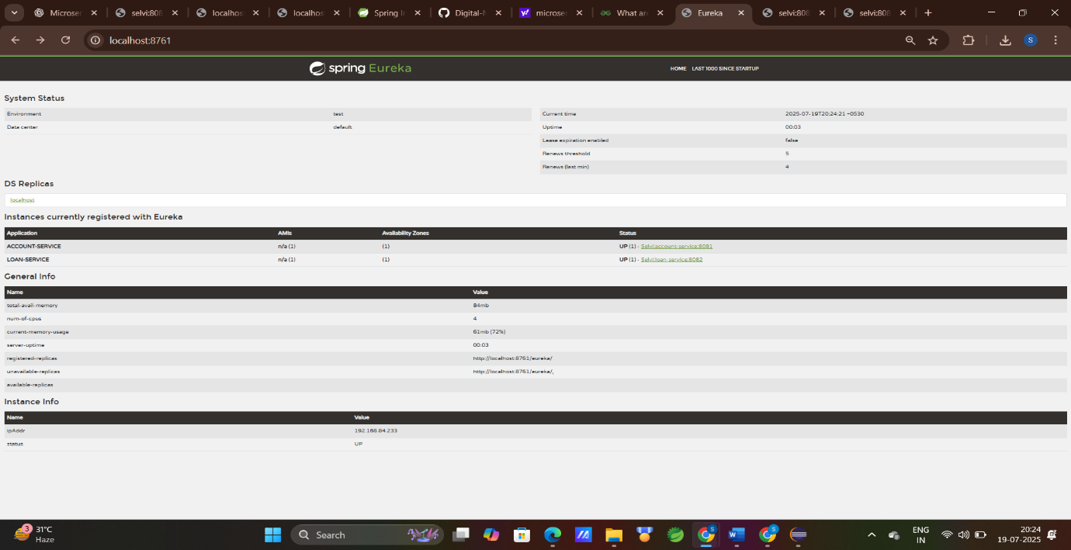



Port : <http://localhost:8081/accounts/123456>

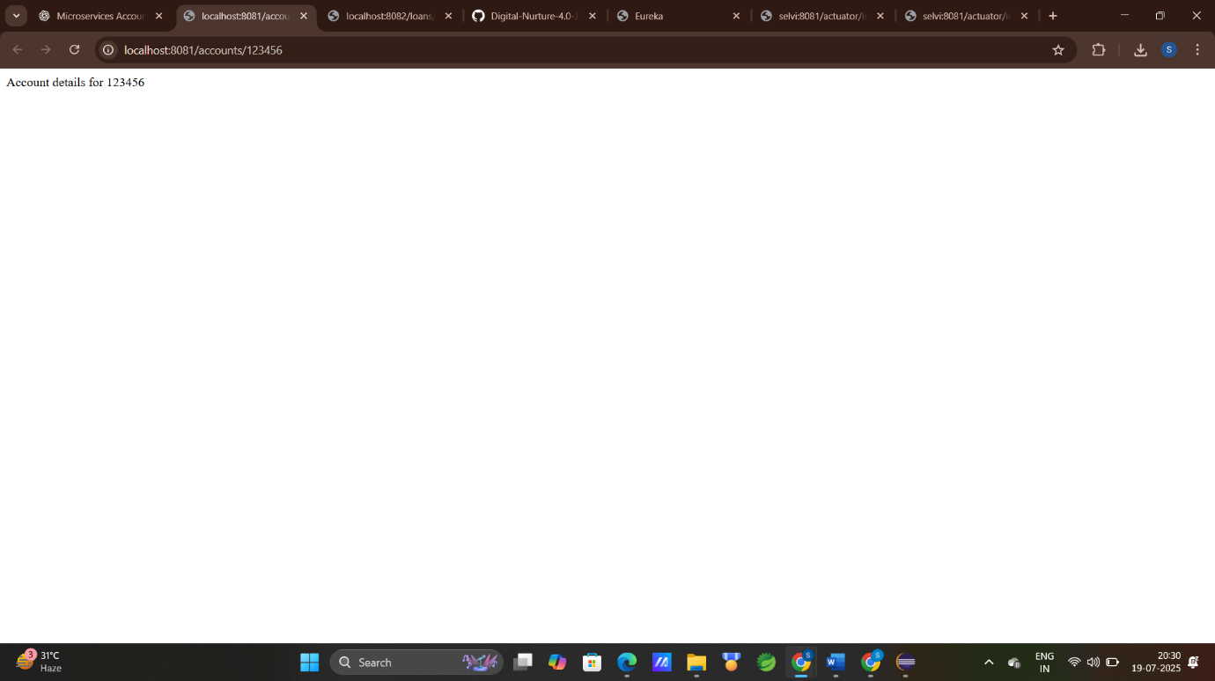

Port : <http://localhost:8082/loans/123456>

